**A**

**PROJECT REPORT**

**ON**

**“Novelty driven AutoRecs Personalized Vehicle Recommendation System”**

Submitted to the





**in fulfillment of the requirements for the award of the degree**

**BACHELORS OF TECHNOLOGY**

# COMPUTER SCIENCE AND ENGINEERING

**2023-2024**

BY

|  |  |
| --- | --- |
| **Himaxi Vachhani** | **2064191242026** |
| **Manasi Chaugule** | **2064191242033** |
| **Mrunmai Kukudkar** | **2064191242036** |
| **Pratham Joshi** | **2064191242046** |

**UNDER THE GUIDANCE OF**

 ***Prof. Tejaswini Zope***

#### DEPARTMENT OF COMPUTER SCIENCE AND ENGINEERING

**PCET-NMVPM’s**

NUTAN COLLEGE OF ENGINEERING AND RESEARCH TALEGAON, PUNE 410507

|  |  |  |
| --- | --- | --- |
|  | **PCET-NMVPM’s**  **NUTAN COLLEGE OF ENGINEERING & RESEARCH TALEGAON, PUNE**  DEPARTMENT OF COMPUTER SCIENCE AND ENGINEERING |  |
|  |  |  |
|  |  |  |

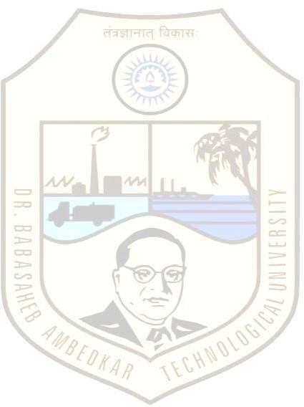 

This is to certify that the Project Report entitled “NOVELTY DRIVEN AUTORECS PERSONALIZED VEHICLE RECOMMENDATION SYSTEM”, which is being submitted by **Himaxi Vachhani**, **Manasi Chaugule**, **Mrunmai Kukudkar**, **Pratham Joshi** as partial fulfillment for the Degree Bachelor of Technology (Computer Science and Engineering) of **DBATU, Lonere**. This is bonafide work carried under my supervision and guidance.

Place: Pune

Date: /06/2024

|  |  |
| --- | --- |
| *Prof. Tejaswini Zope*  **Project Guide** | *Prof. Dhawase D. V.*  **Project I/C** |
| *Prof. Sanjeevkumar Angadi*  **Head of Department** | *Dr. Aparna Pande*  **Principal** |

**External Examiner [Name & Sign]**

# ACKNOWLEDGEMENT

The satisfaction and euphoria that accompany the successful completion of any task would be incomplete without the mention of people who made it possible. So, we acknowledge all those whose guidance and encouragement served as a beacon light and crowned our efforts with success.

We have immense pleasure in expressing thanks to the principal ***Dr. Aparna Pande*** for providing all the facilities for the successful completion of the project.

With due respect, we thank our Head of Department ***Dr. Sanjeevkumar Angadi, Computer Science and Engineering***, for his motivating support, keen interest which kept our spirits alive all through.

We would like to express thanks to our guide ***Prof. Tejaswini Zope*,** Department of ***Computer Science and Engineering*** who has guided us throughout the completion of this project.

Finally, we would like to thank ***all the teaching and non-teaching staff and all our***

***friends*** who have rendered their support in the completion of this report.

Himaxi Vachhani ____________

Manasi Chaugule ____________

Mrunmai Kukudkar ____________

Pratham Joshi ____________

**ABSTRACT**

This project introduces a cutting-edge Personalized Vehicle Recommendation System, using machine learning to offer tailored suggestions based on individual preferences. It addresses the challenge of navigating a vast array of car models,aiming to enhance the user experience through a user-centric approach to car selection.

By integrating machine learning, data science, and software engineering principles, the system showcases a seamless blend of diverse technologies, including collaborative filtering and content-based filtering.Real-world datasets are utilized to train and optimize recommendation algorithms, emphasizing relevance to industry trends and advancements in artificial intelligence within the automotive sector. The project focuses on user-centric design principles, providing hands-on experience in implementing various machine learning models and fostering collaboration with industry professionals.

Overall, the Personalized Vehicle Recommendation System project serves as a comprehensive exploration of machine learning technologies, aiming to contribute to advancements in personalized recommendations within the automotive industry while enhancing the overall user experience.

***Keywords:*** Machine learning, car recommendation system, User Preferences, Features, Random Forest